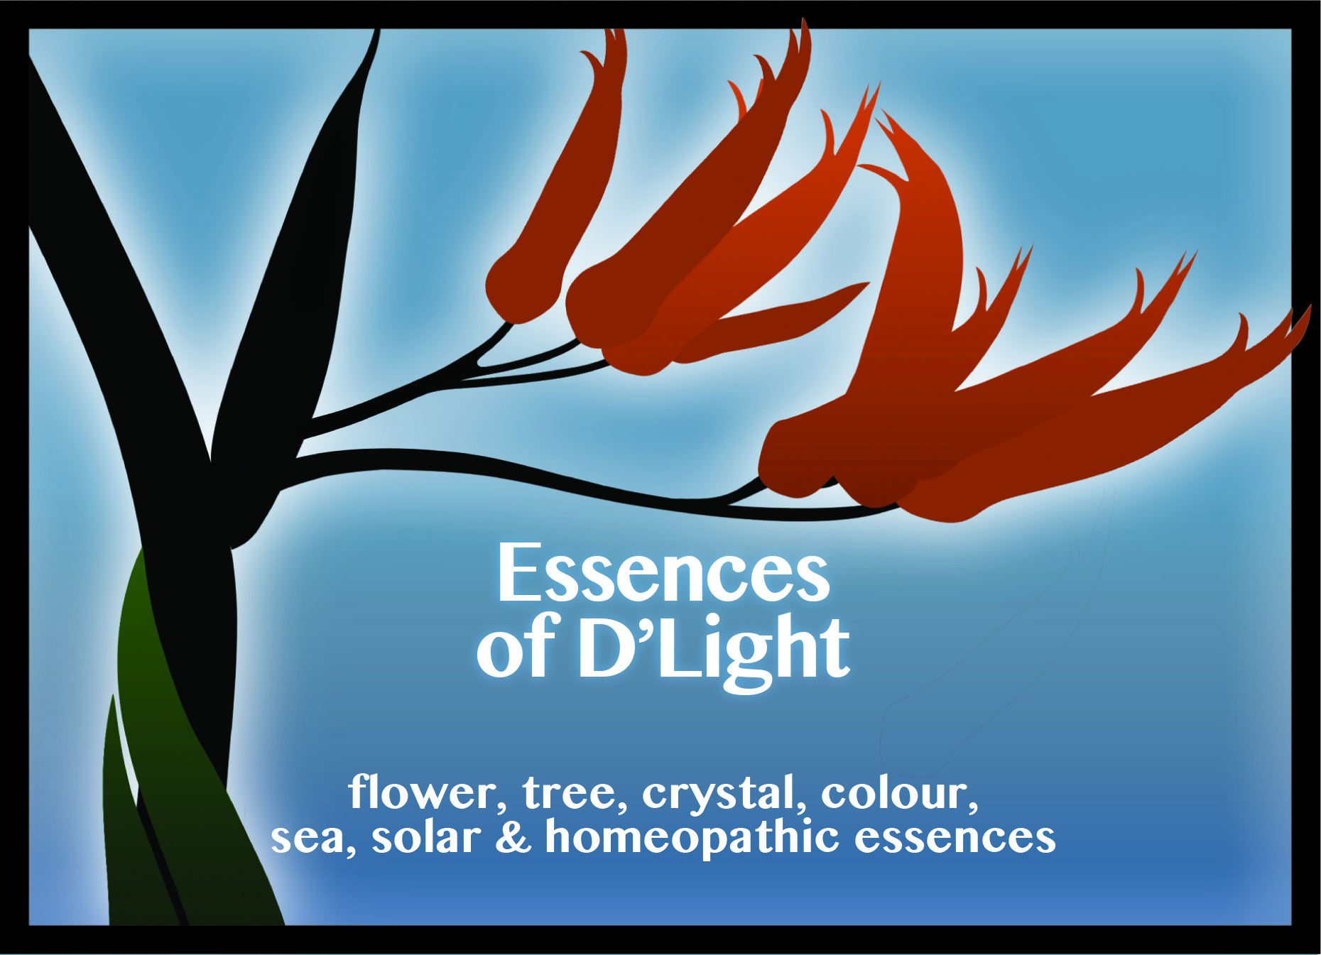
Practitioner Training Workshop
Donna Flavell and
Essences of D’Light

Essences of D’Light
1202 Amohau Street, Rotorua

Friday July 19th 2013 9.00 - 3.30pm

Empowering, Supporting & Sustaining our Clients while Maintaining, Enhancing, & Sustaining our Practise.

The Essences of D’Light Trinity programme with its range of Essences and Wisdom Cards is an invaluable tool to assist you within your practise as well as working wonderful results with your clients.

The Essences of D’Light Trinity programme is an easy to learn and use educational self-help and self-awareness tool.

It allows people to tap into their own wisdom surrounding their issue, to read and understand more about the concepts involved and then to work with a positive affirmation and with a unique essence to help encourage a new commitment to oneself.
The Wisdom Cards allow you to choose from the 28 Concepts and Essences contained within the ‘Essences of D’Light’ range.

Each Wisdom Card includes a unique affirmation.
Speaking the affirmations out loud acts as an intention to let go of outdated thoughts & actions, and allows you to replace these with a new way of thinking and being.

Individuals are supported throughout their process with an Essence, which is described as being your own personalised 'Rescue Remedy', Plus more...

Clients are working on their Physical, Mental, Emotional, and Spiritual Levels, and are making a commitment to change. Therefore, the results are maximised to a far greater degree when used in combination with the Trinity programme.

The Essences of D’Light Trinity programme includes an inspirational Book, which is the foundation of the Programme, providing valuable information & insights as well as more in-depth information about each of the 28 Essences.

Every book comes with a free pack of 28 Wisdom Cards & One Free Essence to help start your journey.

The Essences of D’Light range are unique and are very different from other Flower Essences.
They are combinations of essences derived from numerous other source families or realms. Every Essence of D’Light has a minimum of at least one Essence from the flowers, tree and plant realm, as well as from the crystal, colour, sea, solar, etheric, and universal realms and include specific homeopathic remedies. There are at least five different Essences that are native to New Zealand within every Essence of D’Light.

The special properties are credited with combining the beneficial aspects, positive qualities, and attributes from the many differing energies which combine together to create new energy within a new combined essence.
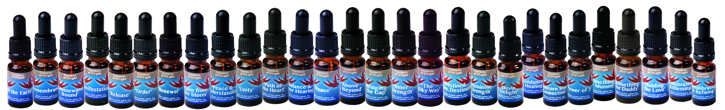
This new combined Essence is therefore capable of assisting a situation from many differing planes. Accordingly, they are very different in the way they act and very different in the frequencies & levels that they can act upon.

Donna will take you through these concepts, helping you to understand the differences between the realms and families and when, where & how to use the remedies.
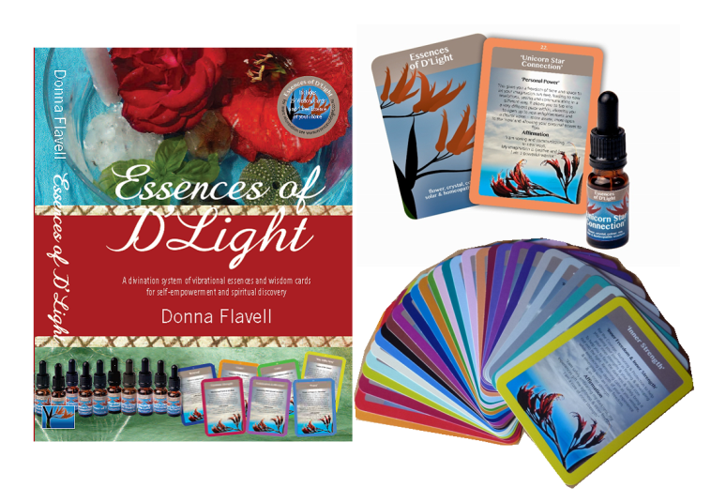
The Essences help on an energetic level, helping to initiate change, with new perceptions and new possibilities, giving powerful yet gentle assistance. All the while, they are helping to support, sustain, and maintain your clients through their progress with increased self-awareness, self-discovery, and self-empowerment, which in turn assists them to experience positive life-changing results.

Drawing on her Maori heritage and Ancestral Wisdom, the Essences have been gathered according to Rongoa Maori -Traditional Māori healing, and the traditional Tikanga or customs.

Maori Healer and Kuia, ‘Taherama Hollis’ has honoured and acknowledged Donna for bridging the use of ancient Rongoā Māori and modern day knowledge to present it in a way that is current, pertinent and understandable in today’s world.

The ‘Essences of D’Light’ programme is simple and easy to understand and use and is an invaluable tool to compliment Practitioners or Therapists for use with, and to support their clients.
Many practitioners say that since using the Essences of D’Light, the changes in their clients have been significant and beneficial.

“Clients have felt much more a part of their own healing process, become more empowered, and supported by using the cards and essences between sessions”.

“... as well as in addressing any challenges or situations that may arise after the shift with their healing session and remedy, clients are much more able to go through, maintain and sustain themselves, without any practitioner support between appointments.”

“A very welcome added bonus has been the word of mouth referrals from raving fans, which have increased significantly.”

“After discussing their Practitioner / Consultation experiences with others, new clients coming from these referrals have been far more ready and open to address their past traumas, face confronting issues or to resolve issues of depression or addiction etc, without the fear they would previously had.”

By allowing clients to choose a card at the end of their session while you are either verifying or dispensing their remedy, or completing notes, gives a non-pressured and well-rounded end to a session.

Clients are amazed at how often the Wisdom Card and Essence they choose so neatly reflects the issues of the session that have transpired, they feel confirmation on a deeper level that they are on the right track, and ready to leave to face the next stage on their journey.

If you want to know more about how you can also incorporate the ‘Essences of D’Light’ Trinity Programme into your practise; to help sustain and support your clients to a deeper level and to sustain and maintain your energy, while also enhancing your practise, then book your place now as numbers are limited to 20 places.
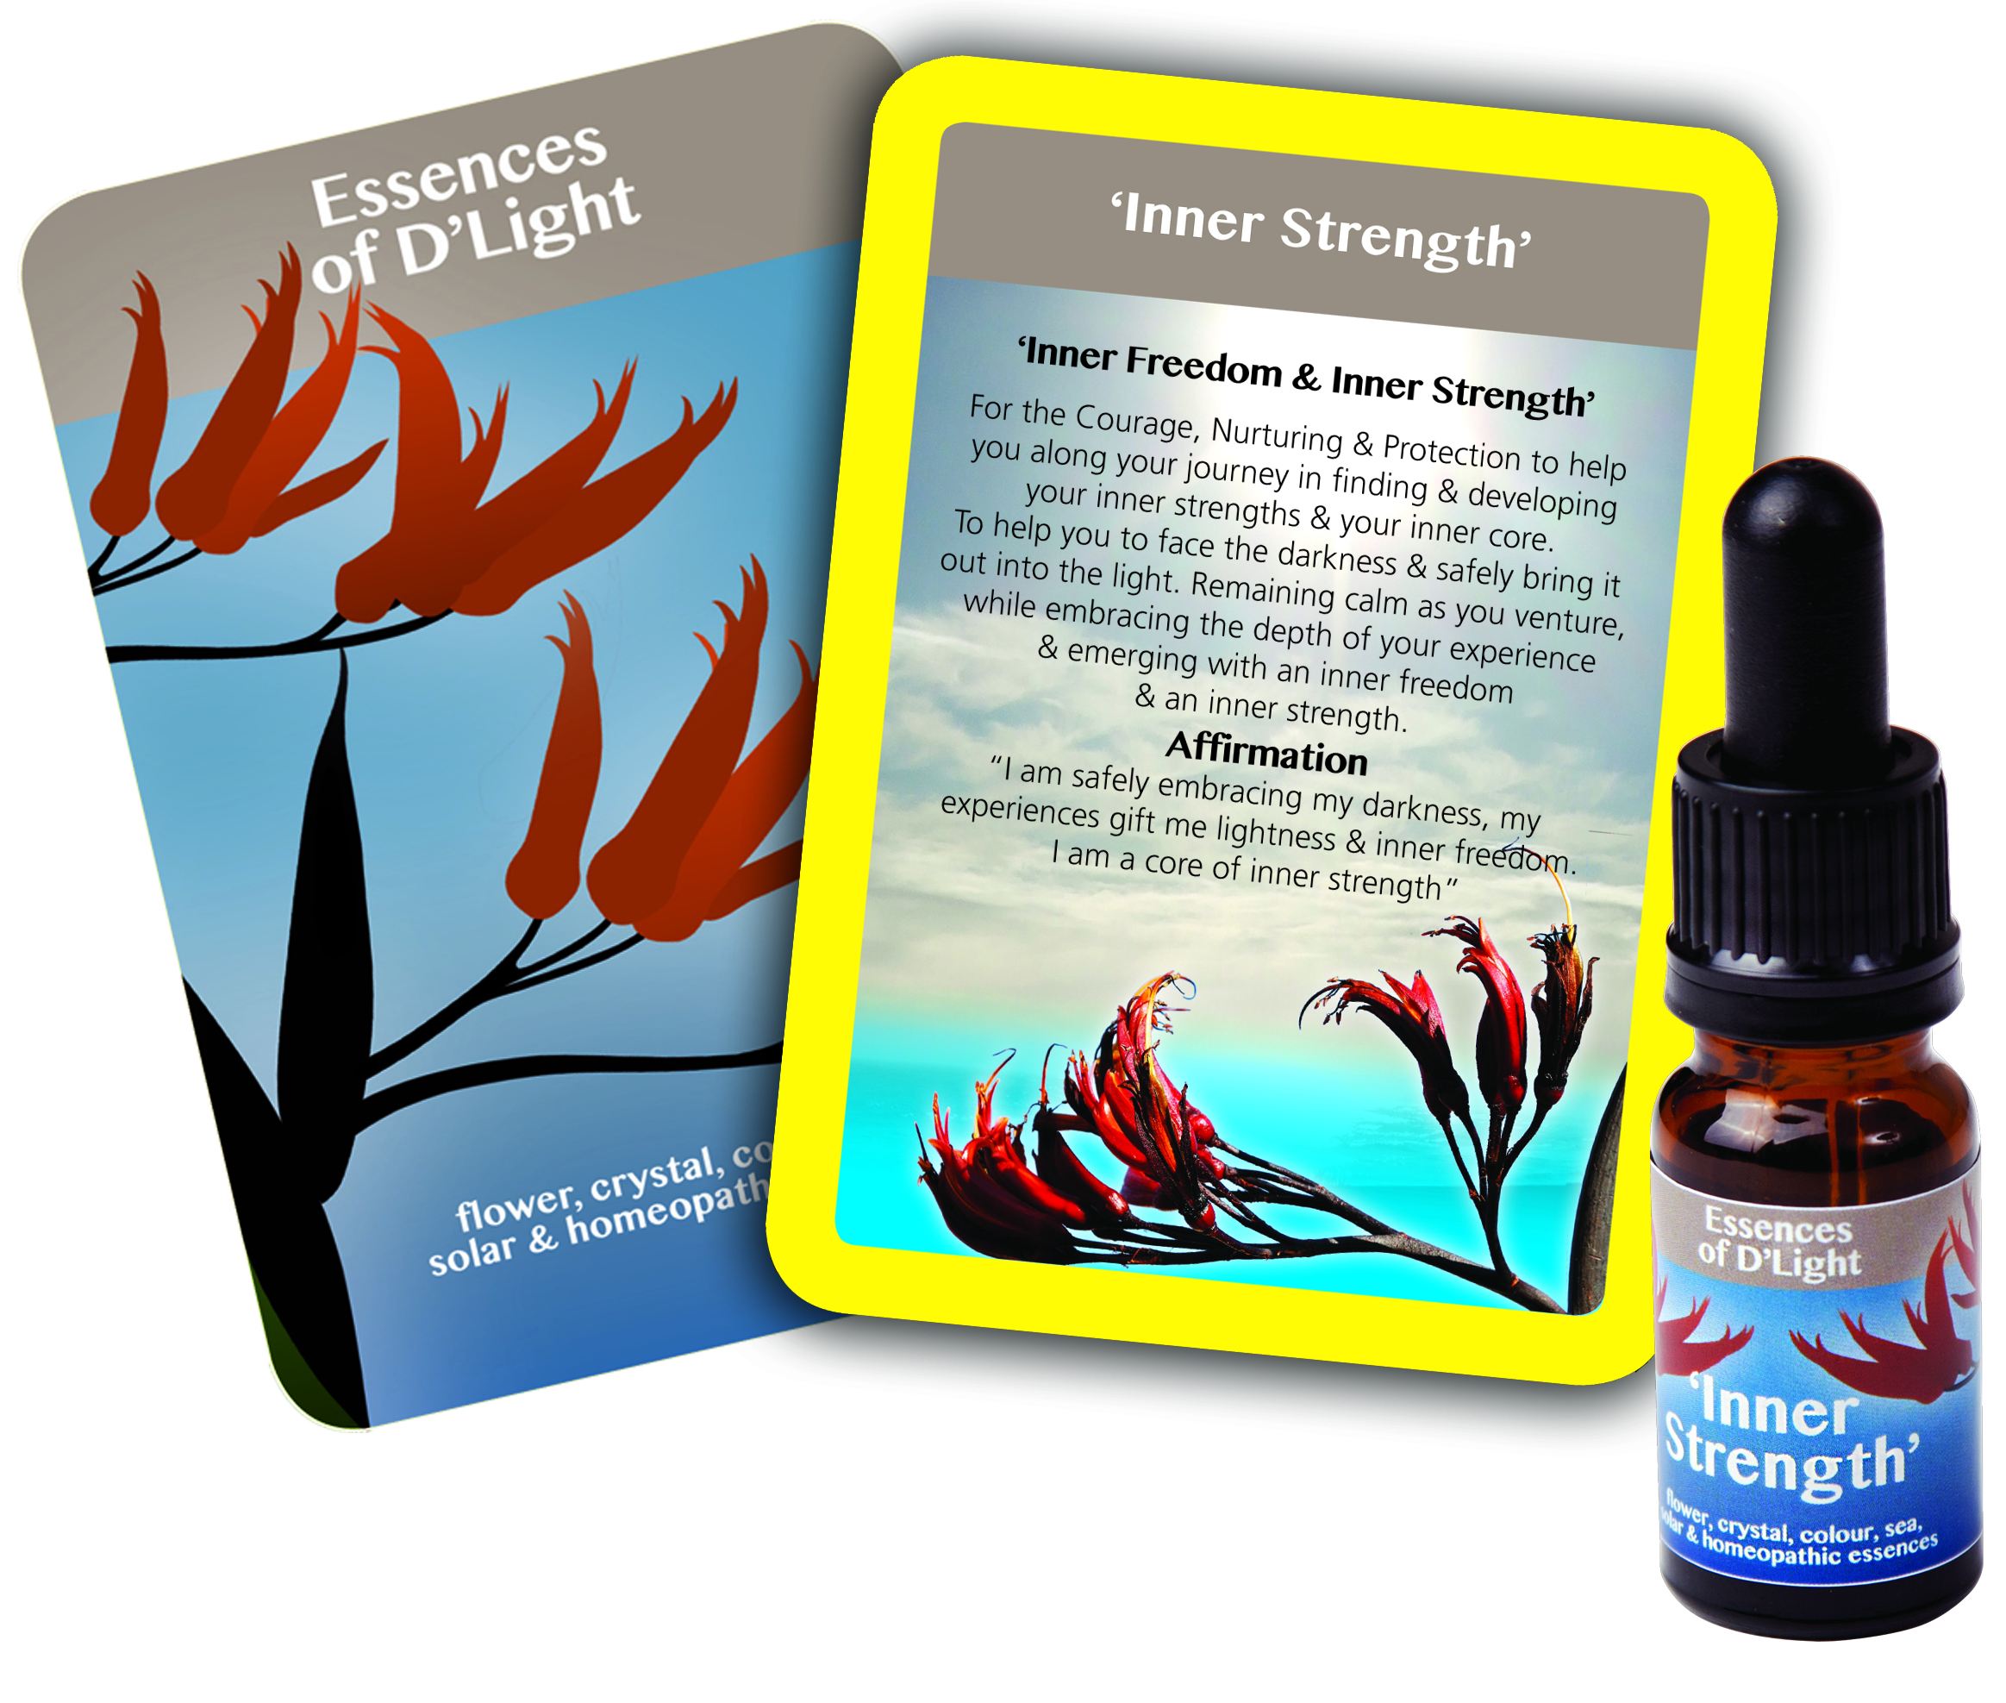
Donna Flavell is a Registered Classical Homeopath, an Author, and a Creator of Vibrational Essences and has created the ‘Essences of D’Light programme and range of products.

Donna runs a multi modality Health & Healing Centre, where Vibrational Essences and Life Awareness Coaching are a core part of her Homeopathic practise, She is still very hands on with clients, while also running training courses, and promoting the Essences of D’Light both in NZ and overseas.
Her passion has always been helping others to help themselves through self-awareness, self-discovery, and self-empowerment. This is a very fundamental basis of the way she practises and the programme.

Donna has a vast and varied knowledge of differing forms of energies, energy healing and alternative modalities. Her thirst for knowledge and has taken her far and wide, and spans over two and a half decades within in the health and healing industry. She has been using Homeopathy and Essences for over 24 years

She gained her Diploma in 1996, studying at the Bay of Plenty College of Homeopathy and become registered with the NZ Council of Homeopaths, formerly known as Institute of Classical Homeopathy in 1997. She is a Registered Member of the ‘Natural Health Practitioners of New Zealand’, the ‘Natural Health Council (NZ) Inc’, the ‘Bio Energy Research Society Inc’, and ‘Flower Essences NZ Inc’.

Donna is also a Registered Member of the prestigious ‘British Association of Flower Essence Producers’.

In clinic, Donna would see many of her clients facing very similar daily challenges in their personal, relationship and business lives - challenges that held them back from living a fulfilling and enjoyable live and being all they could be - for themselves, their loved ones and within their career.

As a Homoeopath, she could treat & help many people on a one to one basis but there were so many more people out there calling, so began teaching Homeopathy to Community Education classes, Play Centres and other outlets. Still she could only touch a limited number of people each week, yet Donna wanted to reach out and help so many more and on a much wider scale. She was also very aware of the importance to maintain as well as sustain her own energy and life balance and not burn out herself in the process.

Drawing on the numerous other modalities and therapies she had trained with and experienced over the previous years, Donna wanted to find a way to take up and incorporate the very best from each therapy, then combine them in a manner that was practical and easy to use for everyone.

Her goal was to create a product or programme that was easy for Practitioners to incorporate into their every day practises, as well as being highly beneficial for individual people to work with, along with their families and loved ones, in their personal, relationship and business lives. She has definitely succeeded in doing this with her Essences of D’Light Trinity Programme.

Practitioner testimonials:

‘..., the feedback I am receiving from my patients is already overwhelmingly positive. It's great to be able to give my patients a daily support therapy that they can take alongside their homeopathic remedy and they love having the beautiful cards to read and keep. Janine Mawson - Homeopath

I have used many essences in my practice over the years and have been pleasantly surprised to see how effective these new remedies have been in treating emotional imbalances. The blend of flowers, sea, and homeopathy offers a unique way of treating that enables them to touch many different areas within the 1 remedy. Alicia Melrose - Medical Herbalist

I have found Donnas’ Guidance in Healing essence incredibly helpful in my practice. Not only do I feel more grounded when with clients but I also feel that I am able to maintain a sense of connectedness with ease throughout the session with my clients and I also feel a greater trust in my intuition, communicating what I feel intuitively and easily to my clients.
Eve Glover - Massage and Reiki Therapist

For more information about Essences of D’Light please visit www.essencesofdlight.co.nz

For more information about Flavell Homeopathic & Healing Centre, visit www.flavellhomeopathy.co.nz

For any enquiries, please phone 027 574 9007 or
Email: info@essencesofdlight.co.nz
REGISTRATION FORM
Practitioner Training Workshop with
Donna Flavell & Essences of D’Light

Empowering, Supporting & Sustaining our Clients while Maintaining, Enhancing, & Sustaining our Practise.

Friday July 19th 2013 9.00 - 3.30pm

The Rotoiti Boardroom, BNZ Partners Business Centre, 1202 Amohau Street, Rotorua

Name: ______________________________________
Address: _____________________________________
Telephone: ___________________________________
Email: _______________________________________

TRAINING WORKSHOP FEES Incl GST

If received before July 1st
Workshop Fee $100.00

Essences of D’Light Book & Wisdom Cards $ 57.50

If received after July 1st
Workshop Fee $120.00

Essences of D’Light Book & Wisdom Cards $ 75.00

Cheque: Payable to ‘Essences of D’Light’

Internet: ASB: 12-3136-0033710-02
(Please quote your name & Rotorua as reference)

- Please return you form & payment to:
PO Box 239 Mangawhai 0540, Northland
- Details & enquiries may be emailed to:
info@essencesofdlight.co.nz
- Phone enquiries to: 027 5749007
Morning & afternoon tea/coffee is included

“When I first met Donna, I was awed by her wealth of knowledge and how she so honestly taught people from her heart.

Growing to know Donna as a friend, I have also learned of her great will to empower people so that they may grow and empower those around them.

I feel this book and the Essences she so cleverly created are a great example of how she can reach and enable as many people as possible to grow and shift to be on their right path and have empowered lives.

I have worked with energies for many years, but Donna enabled me to shift to a whole new level, with a greater perspective of possibility. I feel this is a very timely release of these much-valued Essences and this very informative and inspiring book.

I trust you will be as inspired as I have been.”

Their energy is subtle and gentle yet they have an underlying strength that will shift you.

The essences have the ability to take you to a new state of awareness and work in a next level of consciousness.

They open you up to yourself giving you clarity. Whatever the concept of the essence, this is how they will assist- allowing your own healing to take place and bringing about a conscious awareness of one’s self.

Julie Cunningham
Body of Light
Wellness Practitioner

